**Data - Distribution:**

* Training Data - (2708)
* Test Data (train-test split) - (678,_)
* Validation Data (unseen data) - (582,_)

**Only Renewal Data:**

Attributes used for model training:

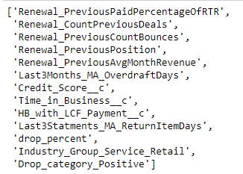

* These are the best attributes given to the model
* Other attributes are dropped due to high missing values, due to very high correlations, and categorical variables.

Model Summary:-

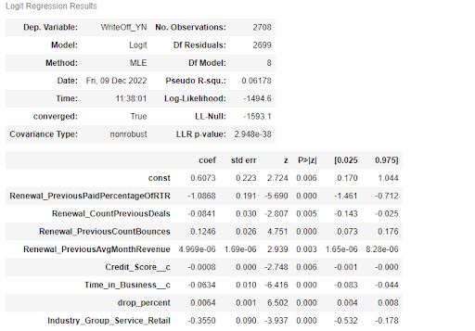

* Ideally
  + P < 0.05 (Statistically significant attribute)
  + P > 0.05 (Statistically insignificant attribute)
* Ideally
  + log_likelihood - should be close to 0 (0 is the ideal model)
  + try to maximize it
* Ideally
  + Coefficients (b0, b1, b2 . . ) and Log_Odds

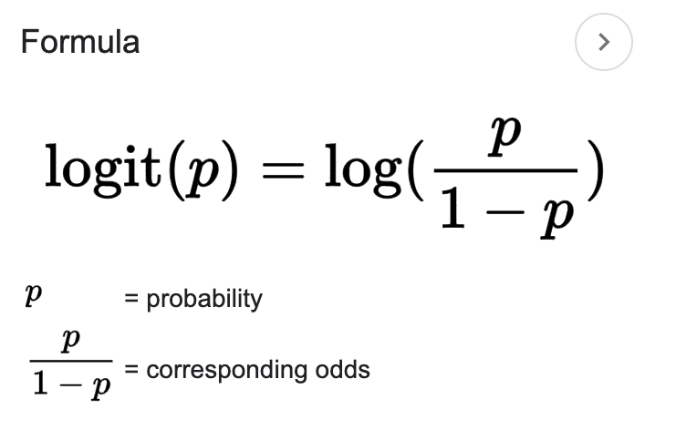

= b_0 + b1*x1 + b2*x2 + . . .

* + +ve coefficient - directly proportional to write_off
    - If +ve ren_countbounces - more chances of write_off
  + -ve coefficient - inversely proportional to write_off
    - If more credit_score - less chances of write_off

Train set:-

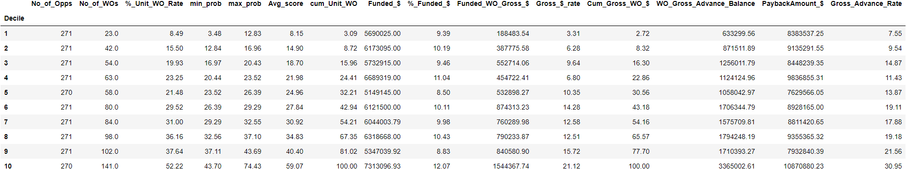

Test set (Split):-

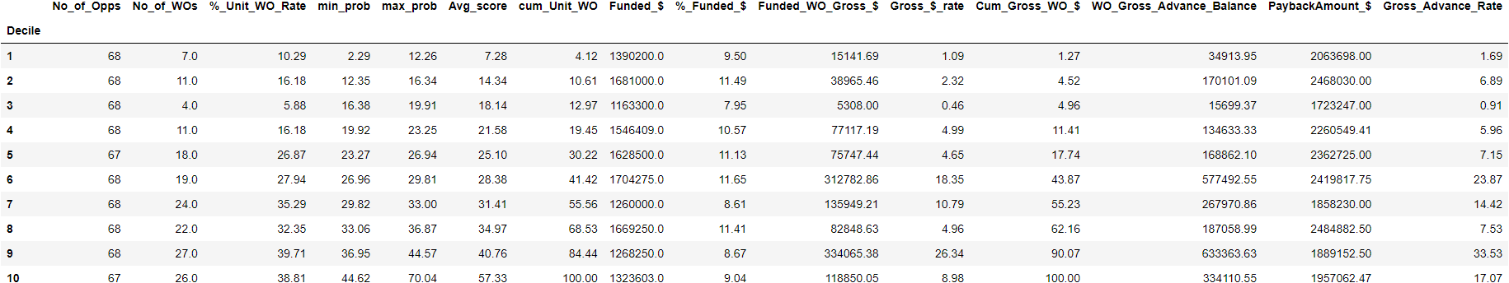

Validation set:-

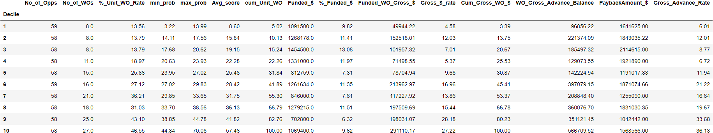

WHat terms should I study